Know Before You Go – NACAS Regional Conference at WashU, SLU and STLCC (April 7–9, 2026)

The NACAS Regional Conference is right around the corner! We look forward to welcoming you to the beautiful Washington University in St. Louis Danforth campus, Saint Louis University and the Saint Louis Community College for three days of learning, networking, and connection.
Our EVENT APP is the website for the conference. Scan the QR Code for more information and for the most up‑to‑date conference details, including session schedules, speaker profiles, maps, and announcements.
https://nacas.org/about/regions/nacas-central/conference/
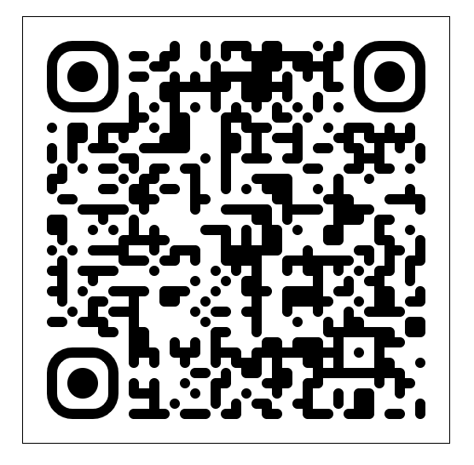
REGISTRATION DESK for NACAS registration pick-up and badge.
- Day 1 Location: Wash U Knight Center – 2nd Floor Lobby (8:30 am -5:00 pm)
- Day 2 Location: SLU Grand Hall Lobby (across from the Grand Hall Dining room from 7:30 am -12:00 pm)
- Day 3 Location: WashU Knight Center – 2nd Floor Lobby (7:00 am-1:00 pm)
(Registration badges are required for entrance to all NACAS activities, sessions and special event locations).
AGENDA & CREDIT
- Explore the AGENDA tab on the conference website schedule or the QR code.
- CASP credit: after the conclusion of the conference all attendees will be sent a survey to assist in documenting their CASP credit for session attendance.

BUSINESSS PARTNER EXPO INFORMATION
- The Expo is located at Saint Louis University – Busch Student Center – Wool Ballroom 20 North Grand Blvd, St. Louis, MO 63103 (314) -977-6338
- Booth set up/removal schedule:
  - Tuesday, April 7, 2026, 6:00 pm-11:00 pm**
  - Wednesday, April 8, 2026, 8:00 am – 11:00 am
  - Tear down may occur either after the expo closes on Wednesday or Thursday morning
- To ship packages directly from the Busch Student Center after the Expo, you must provide your own return shipping labels, packing tape and shipper account number. Once your materials are ready to ship, please notify a member of the NACAS Central team or the Busch Student Center Staff, and your packages will be transported to the student mailroom.
- SLU Parking:
- For the garage, all attendees will enter the garage and get a ticket at entry. Please go left once you enter the garage, to park in guest parking. The garage gates will be open to exit during these times: Wednesday, April 8, 2026: 2:00 pm-8:00 pm
- **For Business Partners setting up on Tuesday evening please request parking pass at registration on Tuesday at the Knight Center
ANNUAL REGIONAL MEETING
Thursday, April 9 at 8:15 am – 8:45 am in room 211 of the KC this will contain a budget review, leadership updates, and a sneak peek of the 2027 conference
EXPO at SLU will be at the Busch Student Center in the Wool Ballroom
- Hours 12:00 pm - 4:00 pm, Wednesday, April 8
- Lunch 12:30 pm - 1:45 pm in the center of the showcase
- Coffee/Tea and Kaldi’s – 1:45 pm -2:30 pm in center of showcase
- Flip-a-Coin* and Silent Auction 2:15 pm – 3:00 pm NACAS table in showcase
- Business Partner mingle -open bar 4:30 pm-5:30 pm
NETWORKING OPPORTUNITIES
Opening Reception, regional breakfasts, Expo meals, closing event, and attendee-to-attendee connections in the agenda
OPENING & CLOSING EVENTS
Opening Reception: Tuesday, April 7 at 7:00 pm – 9:30 pm at The Missouri History Museum- shuttle provided from the hotel and free parking is available at the Museum.
https://mohistory.org/museum
Closing Event: Thursday, April 9, at The Foundry https://www.cityfoundrystl.com/ come experience the Puttshack – shuttle provided from the hotel and free parking is available at City Foundry.
https://www.cityfoundrystl.com/directory/puttshack

TOURS

All tours are limited capacity – if you plan on attending a tour you must have selected the tour during your initial registration. Please confirm during registration at badge pick up if you will be joining any tours. (Limited seating on the shuttles may prohibit additional attendees). Parking is available at WashU, SLU and STLCC.

HELPFUL HINTS
Attire: Business/conference casual; bring comfortable shoes and a light jacket. Our temperatures fluctuate this time of year.
- 1st Day clothing theme – NACAS gear (wear your NACAS shirt, pin, tie, and support our NACAS Regional
- 2nd Day clothing theme – Pride in your school or University by wearing themed colors or the logo of your favorite university
- 3rd Day clothing theme – Business casual, just remember it is Ritz Carlton day!
Transportation: Closest airport is STL (15 minutes). Ride‑share drop‑off available at Knight Center. Metro has limited options but please check out their options at https://www.metrostlouis.org/
Connectivity: Complimentary Wi‑Fi available at each of the conference hotels – please ask at the front desk when checking in.
*The NACAS Foundation's "Flip-A-Coin" supports professional development initiatives—including the DIAL Program, CASP certification, scholarships for students and professionals, awards such as the David H. Lord Award for Exemplary Community Service, and research efforts. Flip-A-Coin provides a meaningful way to contribute to these programs and help expand access to these valuable resources. Attendees purchase beads or tickets to participate, often with opportunities to win prizes like iPads donated by partners. The initiative is a key, high-energy fundraiser to support the foundation.

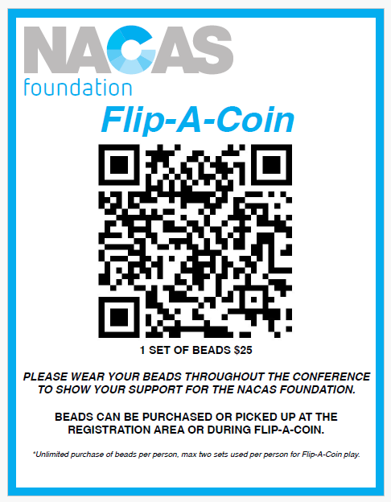
For additional questions or information please don’t hesitate to reach out to our conference committee. gbminner@wustl.edu We can’t wait to welcome you to Saint Louis

